

**BARON MIN**D

August, 2024 beerbarons.org ­­­­­­­­­­­­­­­­­­­­­­­­­­­­­­­­­­ The Monthly Publication of the Beer Barons of Milwaukee Cooperative

_____________________________________________________________________**presidents letter**________________________________________________________________________

This summer is going by so quickly – I hope you are all enjoying the great weather!!! The last officer’s meeting at the Whitnall Park Beer Garden had more members there than any previous one I had been to. There were even 4 Baron Presidents there including myself! I highly encourage you to come to a future Baron board meeting if you have the time. Not only will the club buy you a beer or two, you can also get to see what goes on behind the scenes and give feedback or suggestions for the club and its future.

 I also wanted to remind you that quite a few positions are up for grabs on the Barons board this year. If you are at all interested in becoming part of the club’s leadership next year (and we hope you are) – please come see me or another board member. Remember, for your service to the club, you get a free Gold Card Membership!!!

*Also, we are looking for kegs and possibly volunteers for the Pretzel City Brewfest on September 28th, 2024 in Freeport IL (west of Rockford IL). It will have 10+ homebrew clubs, Pretzels of course, games and more. This festival was voted the best event in IL in 2022.*

Finally – **REMINDER**: The Barons Picnic is coming up very soon. Saturday September 7th! Bring the family, enjoy the food, music, and fun!!!! Remember there will be (2) competitions held that day – One for the member favorite homebrew (Beer, Cider, Mead) and one for the best Food made with homebrew!!! This is one of the most fun events of the year! I highly encourage you to buy tickets ahead of time so we can gauge attendance and help things flow more smoothly. See you all there! **JOE**

_____________________________________________________________ **vice-presidents Update** __________________________________________________________

I hope everyone had a great time at the meeting last month with Dan from Tabal. Everything I heard from him and club members said it was a fantastic meeting. And to those of you who did reach out asking about 608, Phil and I found a time for him to come by early next year for another meeting.

But back to our regularly scheduled program. This month we have Kristopher of Fermentorium coming by with their wide array of beers. And to those who have the unfortunate luck to be anywhere near me during the Christmas party, know I am extremely excited for the Sweater Weather and want a few tips on how he makes it 9% and so smooth.

Before I go, I am again working with Patterson Orchards this year for another bulk order of cider for our club. The price has gone up from the $6.75 last year, but we haven't negotiated how much that increase will be for us. If you want to get your order in time for our cider meeting next month, please go into the Google Sheet and fill out your information and I will collect it when we hand off the gallon jugs. <https://docs.google.com/spreadsheets/d/1JWfG3Qhpnvl6bvemFcA7N4E6-8jBJpaFavVjsw_Q4WA/edit?usp=sharing>

> 1 <

Aug > Fermentorium with Founder/President and Head Brewer Kristopher Volkman

Sep > Cider Night with Cache Cider owner Ethan Keller, and cider pickup

Oct > Barrel Night with Central Waters

Nov > Belgian Night with Supermoon

Dec > Christmas Party! (and elections)

Jan > oh crap, I need to figure out stuff!

Feb > still nothing

March > Stout verticals?

April > 608 with owner and brewmaster Phil Humphry **KYLE**

______________________________________________________________ **TREASURERS REPORT** ______________________________________________________________________

Current Membership: 116

Last Meeting Attendance:

* Guests: 7
* New Members 3
* Gold Attendees: 40
* Member Attendees: 26
* Total Attending: 76

New Members Since: 1 RAND

**This Months Thought:**

**Summer is almost over, it’s time for a picnic!**



> 2 <

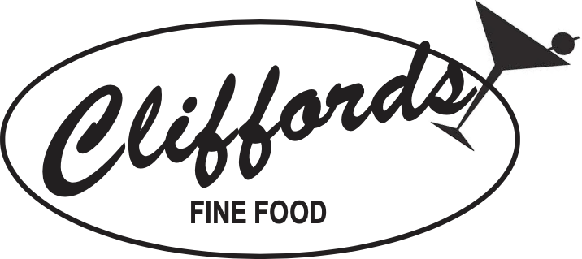

**PLEASE SUPPORT**

**Clifford’s Supper Club**

**Friday Fish Fry**

Weddings, Rehearsal Dinners, Baptisms, Birthdays,

Showers, Anniversaries, Funerals and Family Gatherings

**Wed. Karaoke Wally’s 65 Cent Wings**

**Karaoke Every Wed, Fri, & Sat – 9:30 pm**

**Clifford’s offers the use of their banquet room to the Beer Barons at a reduced rate. Our support will show our appreciation.**

**10481 W. Forest Home * Hales Corners**

**(414) 425-6226 \*** [**www.cliffordsfinefood.com**](http://www.cliffordsfinefood.com)



It's time for the Barons Summer Picnic again! This year it is on **Saturday, September 7th** . It will be held at  [**Root River Parkway Picnic Area 3, Greendale, WI 53129**](https://www.google.com/maps/dir/Greendale,+WI+53129/@42.9478187,-88.1024142,12z/data=!4m8!4m7!1m0!1m5!1m1!1s0x88050e236cedc01b:0x269cc55160f1b13c!2m2!1d-88.0200821!2d42.9477993?entry=ttu). Don’t forget to bring your homemade beer, mead, cider and if it is voted as the best by the other Barons members, your name will be added to the Jerry Hetzel Memorial Mash Paddle. In addition, there will be the ‘Food Made with Beer, Mead or Cider’ Competition (FMBC) again. Prizes will be given out to the winners of both competitions. It is always fun to taste what kinds of food and beers the members come up with. If you choose, you may also bring a dish to pass for others to try, whether it has beer in it or

> 3 <

not, as well as games, both lawn & table, chairs, pop-up tents, tables & towels. We will have a bunch of great prizes in the give-a-way again, so plan ahead if you want to participate. The cost of the picnic is $10 per individual and $15 per couple, kids under 18 are free but they must be accompanied by a parent and please bring something for them to drink. It will start at noon and food will be served at approximately 1:00 p.m. You can purchase tickets online on the Beerbarons Store. Please purchase your tickets ahead of time so that we can plan for food accordingly. Looking forward to seeing you all on the 7th! Thanks.

**Jared Sutliff**

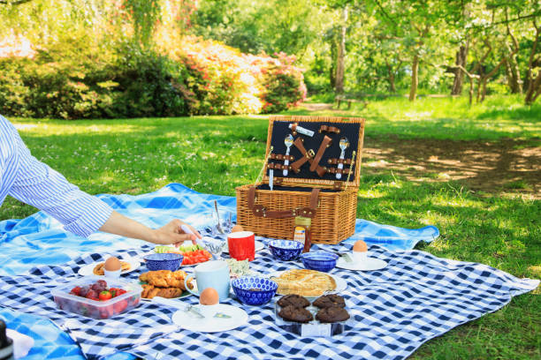

**WEHR NATURE CENTER UPCOMING EVENTS**

On Sunday, September 15th from 11 am to 2 pm The Wehr Nature Center is having a Brunch for

the Bees. This is a one-of-a-kind celebration for Wehr’s 50 years of providing “A place for all

seasons, a place for everyone.” There will be food, music, silent auction and a guest speaker. Tickets are $80 per person and all proceeds go to the center. For more information, go to <https://www.friendsofwehr.org/pollinator-brunch>. Wehr’s address is 9701 College Ave. in Franklin. It is part of Whitnall Park.

***Also:*** on Sunday, October 6th at the Wehr Nature Center there will be what is known as Cider Sunday. It will be at the Wehr Nature Center from 11:30 am – 4:30 pm. Meet Johnny Appleseed,

Listen to music, join a scavenger hunt, hike the trails and much more including apple treats and handmade apple cider beer provided by us, the Beer Barons. For more information on this, go to

**https://www.friendsofwehr.org/cidersunday.** The cost is only $7.00 per person which includes

parking and a lot of fun for the family. Also, you will see at least one familiar face serving the beverages. Check these events out. **Jared Sutliff**

> 4 <

**\* * *Milwaukee Brew Fest * * \***

Word around the club is that Brew Fest was very busy at our booth this year. There were 18

different beers donated, however there were only 14 places on the jockey boxes to serve

them. Better too many than not enough. Thanks go out to Stan, Rahshal, Joe and Tim for

serving and to all the Barons who donated beverages to this yummy cause.

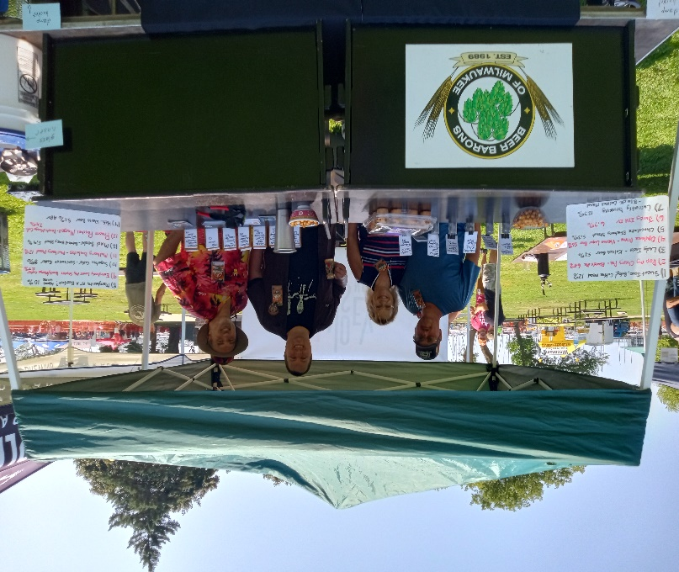 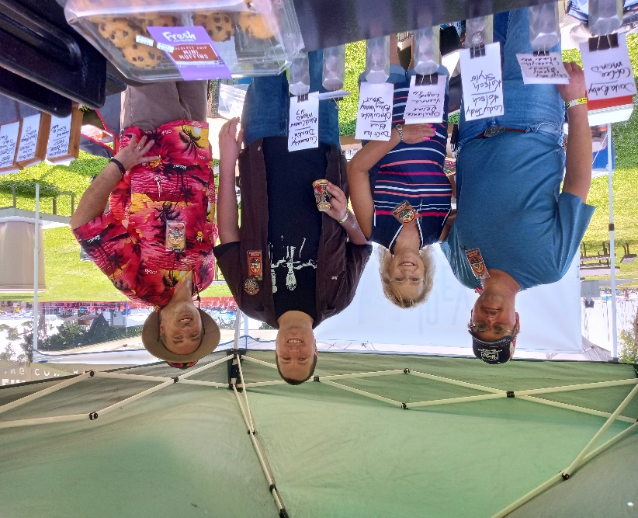

**WISCONSIN** **STATE FAIR**

On Friday, August 9th, the Beer Barons did a Beer Making Demo at the Wisconsin State Fair in the Flower Building (or whatever they call it now.) The members present that are in the picture below are Mike Borchert, Dan Schlosser, Jeff Enders, Lori McDonald and Tom S. Patrick McHugh was also present but missed being in the picture.

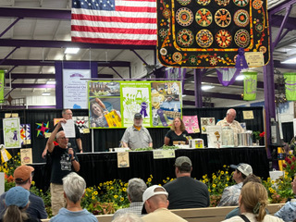

**ALSO**

> 5 <

!Congratulations! go out to Tom Ostrenga for winning Best of Division for Belgian Beers and Best of Division for German Beers at the state fair this year.



September Board Meeting

The next Board Meeting on Wednesday,September 4th, will be held at 3 Cellars in Menomonee Falls.

Their address is N72 W13400 Lund Ln. Suite A. It is on Appleton Avenue just north of Good Hope Rd. The meeting begins at 7:00 pm and usually lasts only an hour. Come and enjoy a beer with us even if you are not on the Barons Board.

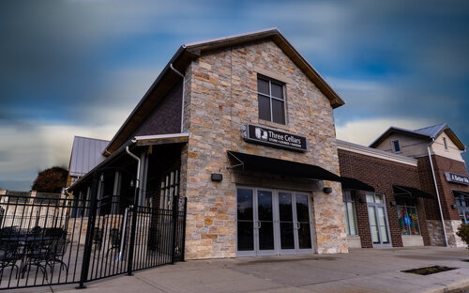

> 6 <

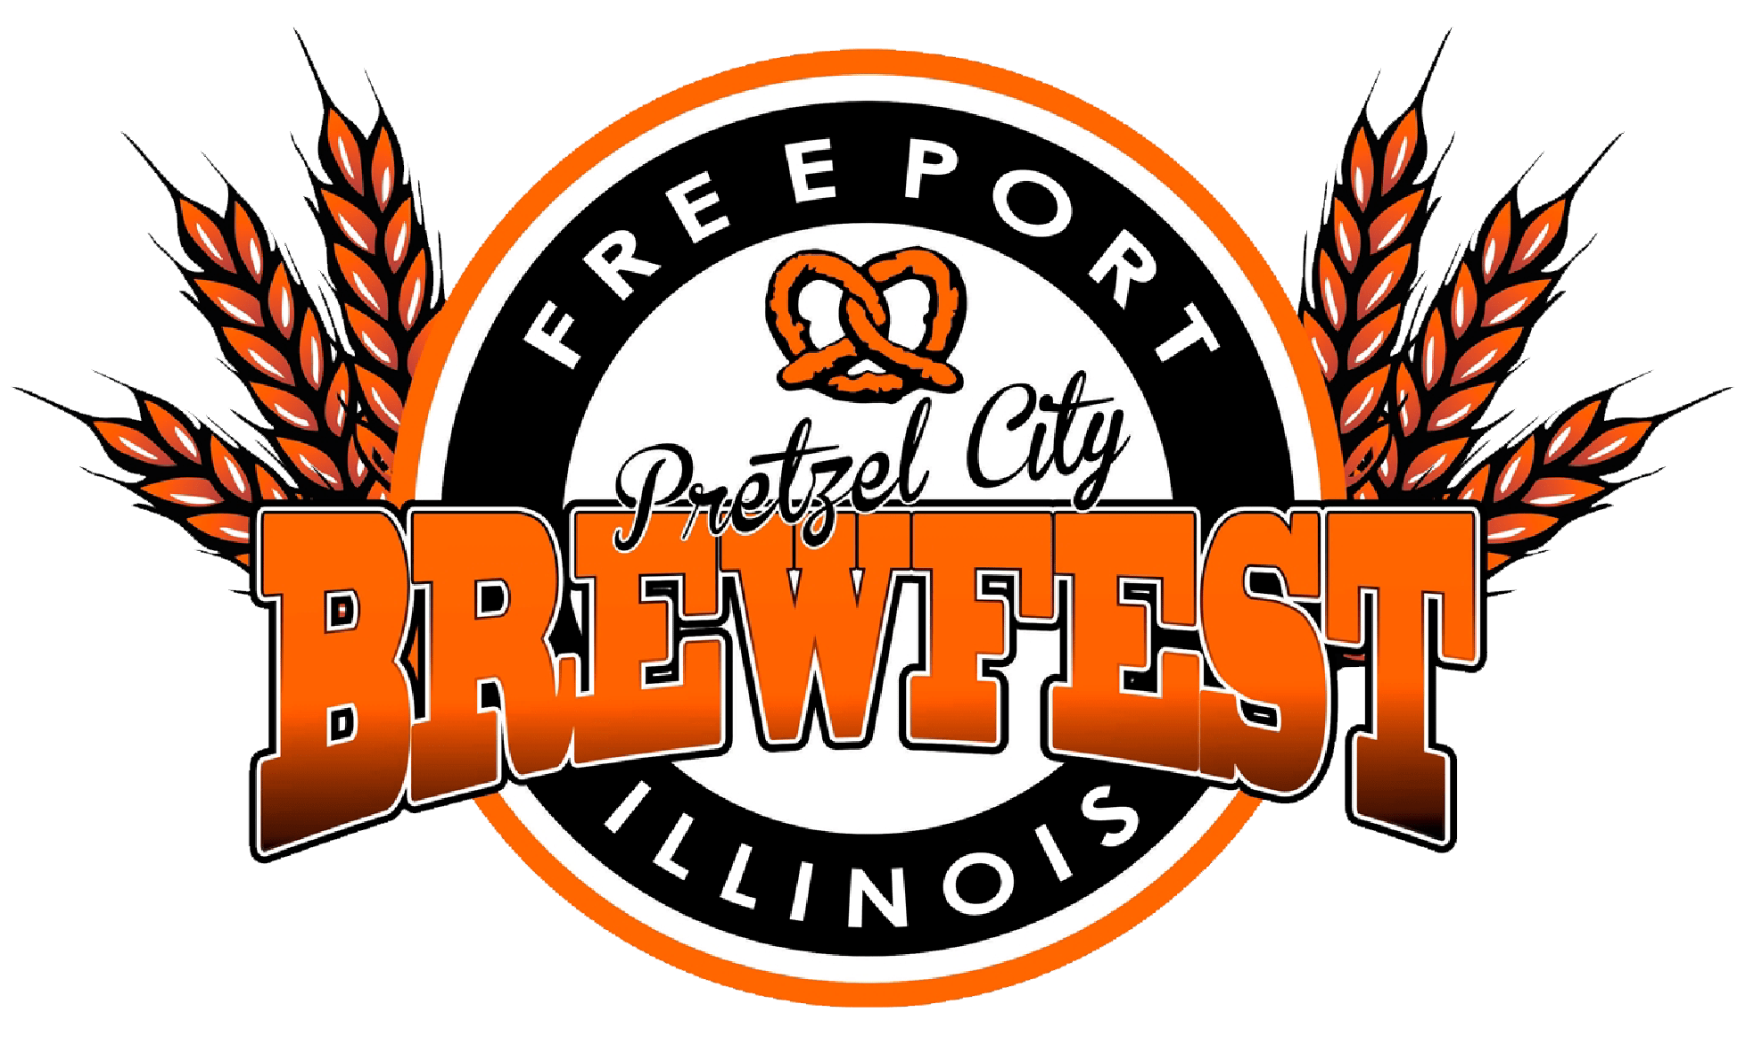 PRETZEL CITY BREWFEST

Several months ago the Barons received an email letting us know about a festival being held in Freeport, IL on Saturday, September 28th, 2024. For those interested in attending I have copied the information from their website:

Pretzel City Brewfest will take place on Saturday, September 28th

in downtown Freeport. This is a 21 and older & rain or shine event.

Tickets can be purchased with credit/debit cards online. VIP will

open at noon with General Admission opening at 1 pm and will

last until 5:00 p.m. Purchase your $40 general admission ticket

online which includes event entry, 20 tasting tickets, and a souvenir

glass. There will be a (very) limited number of $75 VIP passes also

available, which include one-hour early entry, 30 tasting tickets,

access to special releases, a Brewfest t-shirt, a special VIP souvenir

glass, swag bag, VIP lounge, and an option to buy a discounted

limited edition Pretzel City Brewfest hoodie (not available to the

general public). Tickets will be available at the gate for $40 for

General Admission the day of the event, VIP will not be sold the

day of. Designated driver tickets can be purchased on the day of the

event for $10. They plan on having 10-15 home brew clubs involved.

Who knows, we may be one of them. For more information, go the

greaterfreeport.com/brewfest website.

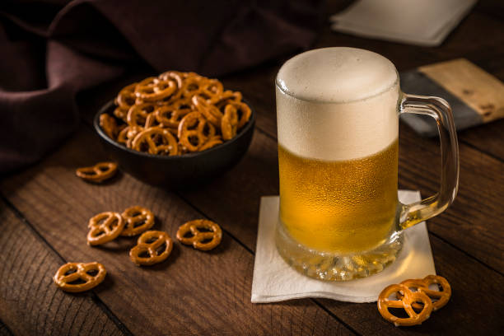 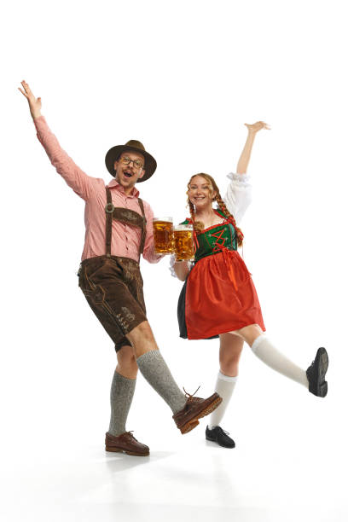

> 7 <

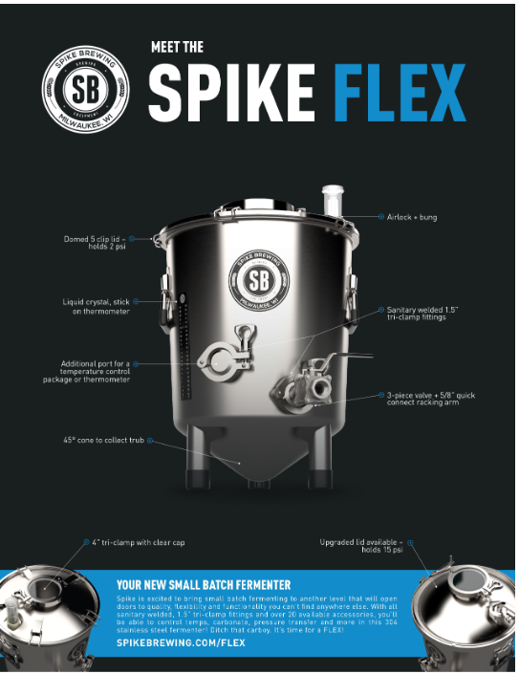

> 8 <

CLUB LINKS 2024 Board Members

Website: beerbarons.org President: **Joe Wichgers**

Twitter: twitter.com/beerbaronsMKE Vice-President: **Kyle Manderscheid**

Facebook: [www.facebook.com/BeerBarons](http://www.facebook.com/BeerBarons) Treasurer: **Rand Lindner**

Brewblog: beerbarons.org/brewblog/ Secretary: **Debbie Minger**

Midwinter Brewfest: twitter.com/MidwinterHBC Sergeant at Arms: **John Bowen**

Member at Large: **Erik Carlson**

Member at Large: **Tim Ruppnow**

Social Media: **Andrew Grove**

IO Group: Contact the Board via email at:

<https://beerbaronsofmilwaukee.groups.io/g/>[officers@beerbarons.org](mailto:officers@beerbarons.org)

BeerBaronsOfMilwaukee Or in writing at:

Beer Barons of Milwaukee Cooperative

P.O. Box 270012

Milwaukee, WI 53227

|  |  |  |  |  |
| --- | --- | --- | --- | --- |
| **Beer Barons - Code of Conduct** | | | | |
| Our goal is to improve our members' knowledge of home brewing and its enjoyment. | | | |  |
| Please show your respect and courtesy to the people you have elected to do the business of this club and the | | | |  |
| guest speakers that are graciously giving their time to come and put on a presentation for you by | | | |  |
| being **QUIET** during the meeting. |  |  |  |  |
|  |  |  |  |  |
| Nothing is to be removed from this room that YOU did not bring in (That means the club beers stay.) | | | |  |
| Please leave all un-opened beer for others to enjoy at other events. | | |  |  |
|  |  |  |  |  |
| NO outside food is allowed to be brought into the meeting that was not purchased at Clifford's | | | |  |
| Only exception is for snack items to enjoy with your beer | |  |  |  |
| * Pretzels, popcorn, nuts |  |  |  |  |
| * Chips & dip |  |  |  |  |
| * Cheese, sausage & crackers |  |  |  |  |
| * Smoked or canned fish items |  |  |  |  |
| **Please bring your own glass and clean up after yourself.** | | | | |
| * Everyone must check-in with the treasurer, show your membership card, and pay your meeting fee | | | |  |
| to receive a wristband. |  |  |  |  |
| * Please put your wristband on your wrist (not on your glass/horn) | | |  |  |
|  |  |  |  |  |
| NO guns or weapons of any kind allowed in the meeting | | | | |
| NO SMOKING allowed in the building | | | | |
|  |  |  |  |  |
| Listen - Learn - Ask questions, someone will have the answer. Enjoy the meeting & guest speakers. | | | |  |

|  |
| --- |
| **Baron Mind** is published by the **Beer Barons of Milwaukee Cooperative**, a non-profit |
| organization. If you have an article or information that you would like to contribute to the newsletter, you can email it to the secretary or mail it to the club's mailing address. |

> 9 <